

**Design Document**

Vehicle

Insurance Management System

**Index**

1. Introduction 3

1.1 Our goal 3

1.2 Our solution 3

2. Customer requirement 3

2.1 User Interface 3

2.2 Manager Interface5

3. How we design of our system 6

4. Functional Decomposition Diagram 7

4.1 Functional Decomposition Diagram - Manager7

4.2 Functional Decomposition Diagram - User7

5. Data Flow Diagram 8

5.1 Context Diagram 8

5.2 Detail Level Diagram 8

6. Entity Relationship Diagram 11

6.1 Entity Relationship Diagram11

6.2 Entity - Attribute 12

7. Data design, Data structure 13

The End 22

**About Our Product**

# 1. Introduction

## 1.1 Our goal

* Customer: Help customers buy insurance for their vehicle
* Admin: Help improve their industries, help reduce strength
* **2.1.1 Home page**
* Banner to introduce the system.
* List of some insurance.
* System contact information.

### 2.1.2 Quote & vehicle

* Fill your vehicle information and get estimate or view insurance what you bought
* Send request for claim detail and see claimed request
* Sort by vehicle type

### 2.1.3 Profile

* Help you manage your information and password

### 2.1.4 Contact

* Show information about our industry
* Show our google map
* If you want to request support, you can fill the form below and click “Send message”

**2.1.7 Customer Support**

* Show information about our industry
* Show Faq’s

### 2.1.8 Register page

* Form to register new account

**2.1.9 Login page**

* Form to login to your account

## 2.2 Manager Interface

**2.2.1 Dashboard**

- Show revenue statistics

### 2.2.2 Vehicle manager

- Manage vehicles (allow to create, edit and delete vehicle)

### 2.2.3 Inside Vehicle Type

- Manage inside vehicles (allow to create, edit and delete inside vehicle)

**2.2.4 Insurance Type**

- Manage insurances (allow to create, edit and delete insurances)

### 2.2.5 Estimate

* View all customer’s vehicle information and give estimate & insurance for them

### 2.2.6 Billing manager

-View all bill from customer and activate bill & insurance for them when they bought success

### 2.2.7 Sitemaps

-Manage sitemaps for websites

### 2.2.8 Customer Support

- Manage Faq for customer

### 2.2.9 Claim Detail

- View and accept claim detail from customer

### 2.2.10 Contacts

- View all customer request and help them

### 2.2.11 Customer Policy

- Storage and manage insurance for customer

### 

# 3. How we design our system

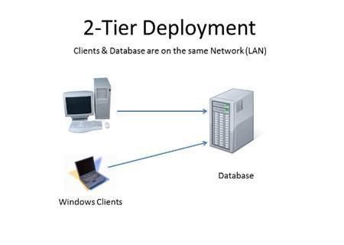

# 4. Functional Decomposition Diagram

## 4.1 Admin side

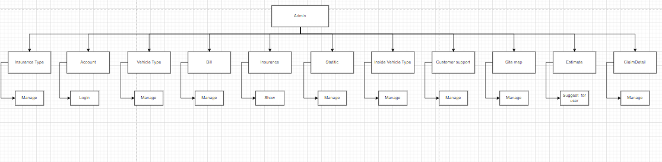

## 4.2 User side

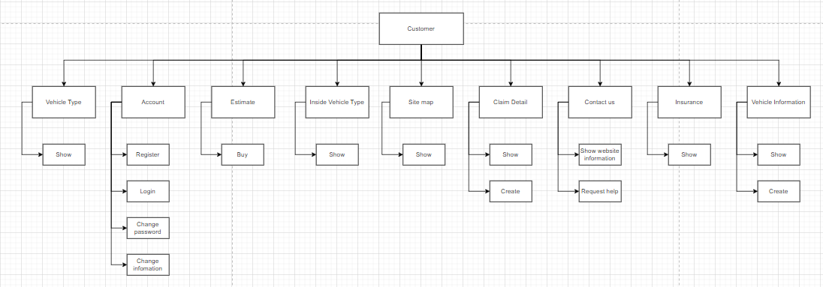

# 5. Data Flow Diagram

## 5.1 Context Diagram

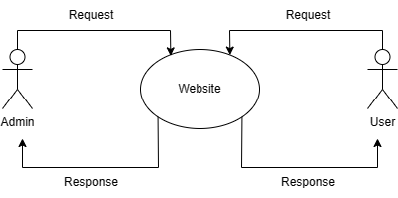

# 6. Entity Relationship Diagram

## 6.1 Entity Relationship Diagram

## 

## 

## 

## 

## 

## 

## 

## 6.2 Entity - Attribute

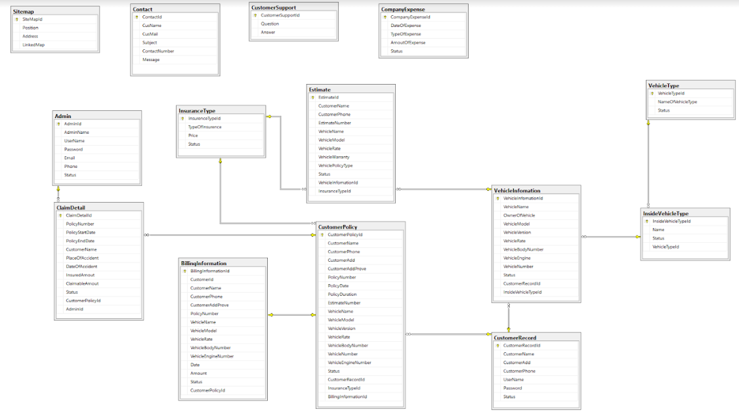

**7. Data design, Data structure**

|  |  |  |  |  |
| --- | --- | --- | --- | --- |
|  |  | Table:Admin | | |
| **Column name** | **Datatypes** | | **Key** | **Description** |
| AdminId | Int | | PK |  |
| AdminName | Nvarchar(max) | |  |  |
| UserName | Nvarchar(max) | |  |  |
| Password | Nvarchar(max) | |  |  |
| Email | Nvarchar(max) | |  |  |
| Phone | Nvarchar(max) | |  |  |
| Status | Int | |  |  |

|  |  |  |  |  |
| --- | --- | --- | --- | --- |
|  |  | Admin:CustomerRecord | | |
| **Column name** | **Datatypes** | | **Key** | **Description** |
| CustomerRecordId | Int | | PK |  |
| CustomerName | Nvarchar(max) | |  |  |
| CustomerAdd | Nvarchar(max) | |  |  |
| CustomerPhone | Nvarchar(max) | |  |  |
| UserName | Nvarchar(max) | |  |  |
| Password | Nvarchar(max) | |  |  |
| Status | Int | |  |  |

|  |  |  |  |  |
| --- | --- | --- | --- | --- |
|  |  | Table:BillingInformation | | |
| **Column name** | **Datatypes** | | **Key** | **Description** |
| BillingInformationId | Int | | PK |  |
| CustomerId | Int | |  |  |
| CustomerName | Nvarchar(max) | |  |  |
| CustomerPhone | Nvarchar(max) | |  |  |
| CustomerAddProve | Nvarchar(max) | |  |  |
| PolicyNumber | Nvarchar(max) | |  |  |
| VehicleName | Nvarchar(max) | |  |  |
| VehicleModel | Nvarchar(max) | |  |  |
| VehicleRate | Nvarchar(max) | |  |  |
| VehicleBodyNumber | Nvarchar(max) | |  |  |
| VehicleEngineNumber | Nvarchar(max) | |  |  |
| Date | Datetime2(7) | |  |  |
| Amount | Float | |  |  |
| Status | Int | |  |  |
| CustomerPolicyId | int | | FK | Foreign key to CustomerPolicy |

|  |  |  |  |  |
| --- | --- | --- | --- | --- |
|  |  | Table:ClaimDetail | | |
| **Column name** | **Datatypes** | | **Key** | **Description** |
| ClaimDetailId | Int | | PK |  |
| PolicyNumber | Nvarchar(max) | |  |  |
| PolicyStartDate | Datetime2(7) | |  |  |
| PolicyEndDate | Datetime2(7) | |  |  |
| CustomerName | Nvarchar(max) | |  |  |
| PlaceOfAccident | Nvarchar(max) | |  |  |
| DateOfAccident | Datetime2(7) | |  |  |
| InsuredAmout | Float | |  |  |
| ClaimableAmout | Float | |  |  |
| Status | Int | |  |  |
| CustomerPolicyId | Int | | FK | Foreign key to CustomerPolicy |
| AdminId | Int | | FK | Foreign key to Admin |

|  |  |  |  |  |
| --- | --- | --- | --- | --- |
|  |  | Table:CompanyExpense | | |
| **Column name** | **Datatypes** | | **Key** | **Description** |
| CompanyExpenseId | Int | | PK |  |
| DateOfExpense | Datetime2(7) | |  |  |
| TypeOfExpense | Nvarchar(max) | |  |  |
| AmoutOfExpense | Float | |  |  |
| Status | Int | |  |  |

|  |  |  |  |  |
| --- | --- | --- | --- | --- |
|  |  | Table:Contact | | |
| **Column name** | **Datatypes** | | **Key** | **Description** |
| ContactId | Int | | PK |  |
| CusName | Nvarchar(max) | |  |  |
| CusMail | Nvarchar(max) | |  |  |
| ContactNumber | Nvarchar(max) | |  |  |
| Message | Nvarchar(max) | |  |  |

|  |  |  |  |  |
| --- | --- | --- | --- | --- |
|  |  | Table:Customerpolicy | | |
| **Column name** | **Datatypes** | | **Key** | **Description** |
| CustomerPolicyId | Int | | PK |  |
| CustomerName | Nvarchar(max) | |  |  |
| CustomerPhone | Nvarchar(max) | |  |  |
| CustomerAdd | Nvarchar(max) | |  |  |
| CustomerAddProve | Nvarchar(max) | |  |  |
| PolicyNumber | Nvarchar(max) | |  |  |
| PolicyDate | Datetime2(7) | |  |  |
| PolicyDuration | Int | |  |  |
| EstimateNumber | Float | |  |  |
| VehicleName | Nvarchar(max) | |  |  |
| VehicleModel | Nvarchar(max) | |  |  |
| VehicleVersion | Nvarchar(max) | |  |  |
| VehicleRate | Int | |  |  |
| VehicleBodyNumber | Nvarchar(max) | |  |  |
| VehicleNumber | Nvarchar(max) | |  |  |
| VehicleEngineNumber | Nvarchar(max) | |  |  |
| Status | Int | |  |  |
| CustomerRecordId | Int | |  |  |
| InsuranceTypeId | Int | | FK | Foreign key to InsuranceType |
| BillingInformationId | Int | | FK | Foreign key to BillingInformation |

|  |  |  |  |  |
| --- | --- | --- | --- | --- |
|  |  | Table:CustomerSupport | | |
| **Column name** | **Datatypes** | | **Key** | **Description** |
| CustomerSupportId | Int | | PK |  |
| Question | Nvarchar(max) | |  |  |
| Answer | Nvarchar(max) | |  |  |

|  |  |  |  |  |
| --- | --- | --- | --- | --- |
|  |  | Table:Estimate | | |
| **Column name** | **Datatypes** | | **Key** | **Description** |
| EstimateId | Int | | PK |  |
| CustomerName | Nvarchar(max) | |  |  |
| CustomerPhone | Nvarchar(max) | |  |  |
| EstimateNumber | Float | |  |  |
| VehicleName | Nvarchar(max) | |  |  |
| VehicleModel | Nvarchar(max) | |  |  |
| VehicleRate | Int | |  |  |
| VehicleWarranty | Nvarchar(max) | |  |  |
| VehiclePolicyType | Nvarchar(max) | |  |  |
| Status | Int | |  |  |
| VehicleInfomationId | Int | |  |  |
| InsuranceTypeId | Int | | FK | Foreign key to InsuranceType |

|  |  |  |  |  |
| --- | --- | --- | --- | --- |
|  |  | Table:InsideVehicle | | |
| **Column name** | **Datatypes** | | **Key** | **Description** |
| InsideVehicleTypeId | Int | | PK |  |
| Name | Nvarchar(max) | |  |  |
| Status | Int | |  |  |
| VehicleTypeId | Int | | FK | Foreign key to VehicleType |

|  |  |  |  |  |
| --- | --- | --- | --- | --- |
|  |  | Table:InsuranceType | | |
| **Column name** | **Datatypes** | | **Key** | **Description** |
| InsuranceTypeId | Int | | PK |  |
| TypeOfInsurance | Nvarchar(max) | |  |  |
| Price | Float | |  |  |
| Status | Int | |  |  |

|  |  |  |  |  |
| --- | --- | --- | --- | --- |
|  |  | Table:Sitemap | | |
| **Column name** | **Datatypes** | | **Key** | **Description** |
| SiteMapId | Int | | PK |  |
| Position | Int | |  |  |
| Address | Nvarchar(max) | |  |  |
| LinkedMap | Nvarchar(max) | |  |  |

|  |  |  |  |  |
| --- | --- | --- | --- | --- |
|  |  | Table:VehicleInfomation | | |
| **Column name** | **Datatypes** | | **Key** | **Description** |
| VehicleInfomationId | Int | | PK |  |
| VehicleName | Nvarchar(max) | |  |  |
| OwnerOfVehicle | Nvarchar(max) | |  |  |
| VehicleModel | Nvarchar(max) | |  |  |
| VehicleVersion | Nvarchar(max) | |  |  |
| VehicleRate | Int | |  |  |
| VehicleBodyNumber | Nvarchar(max) | |  |  |
| VehicleEngine | Nvarchar(max) | |  |  |
| VehicleNumber | Nvarchar(max) | |  |  |
| Status | Int | |  |  |
| CustomerRecordId | Int | | FK | Foreign key to CustomerRecord |
| InsideVehicleType | Int | | FK | Foreign key to InsideVehicleType |

|  |  |  |  |  |
| --- | --- | --- | --- | --- |
|  |  | Table:VehicleType | | |
| **Column name** | **Datatypes** | | **Key** | **Description** |
| VehicleTypeId | Int | | PK |  |
| NameOfVehicleType | Nvarchar(max) | |  |  |
| Status | Int | |  |  |

**The end**